**Step 1 – Specify PuTTy Session**

On Windows, get Putty from <https://www.putty.org/>.

On Linux OS, PuTTy can be install by running: *sudo apt-get install putty* Or *sudo yum install putty*.

On Mac OS, PuTTy can be install by running: *sudo brew install putty*

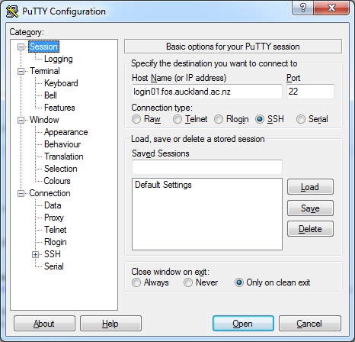

For Science Students, set the Host Name to *login01.fos.auckland.ac.nz*, and Port to 22.

For Engineering Students set the Host Name to *shell.foe.auckland.ac.nz*, and port to 22.

**Step 2 – Setup forwarded port**

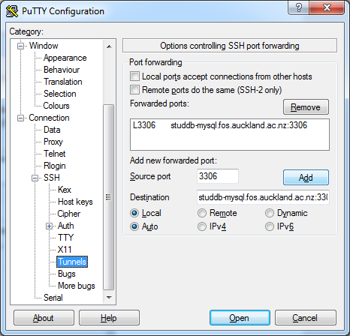

In the Tunnels section, set Source port to 3306, and set Destination to the MySQL server:

[*studdb-mysql.fos.auckland.ac.nz*](http://studdb-mysql.fos.auckland.ac.nz/)*:3306*

Once this is done, click on the “Add” button to create the forwarded port, then the “Open” button at the bottom to start the login Session.

**Step 3 – Start Login Session**

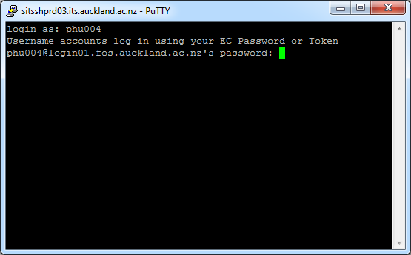

Put your EC user name then password when prompted. Once the Session has been established, keep the session window live as long as you want to connect to the MySQL database server.

Since we have mapped the remote MySQL server port to the local port 3306, The JDBC connection string should look something like:

"jdbc:mysql://127.0.0.1:3306/{database_name}"